MCS98XX Installation Guide

On

Windows 98SE

Note : These instructions are made for Windows 98SE OS, Installation instructions of Windows ME are quite similar to that of Windows 98SE.

The document will present the steps needed to install or update the drivers for MosChip products or another manufacturer’s product based on a MosChip product.

In this installation guide we have taken MCS9835 as an example which consists of
2 serial ports and 1 parallel port.

Following are the steps:

Step1: Download the appropriate drivers from the web site

1. http://www.moschip.com
- Click the Downloads button
- Download the appropriate drivers under the category “PCI Connectivity”.
2. Unzip the driver files to a directory on your hard disk or a floppy diskette.
3. Check for a “Readme” file in the New folder that may have additional or special installation instructions. Use those instructions in addition to or instead of, these instructions if applicable.

Step2: Installing the drivers for the first time.

- Shutdown Windows.
- Insert the peripheral card into the computer.
- Ensure that there are no external devices connected to the ports at this time. (They can interface with the installation of the drivers.)
- Turn the computer ON.
- Windows will automatically detect the card, and will invoke the “Add New Hardware” wizard.

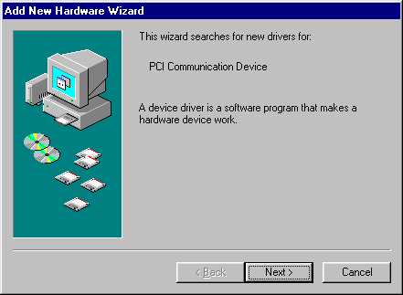

- Click “Next” to continue installation.
- The next dialogue “What do you want Windows to do?” will appear.
- Select “Search for the best driver for your device. (Recommended).”

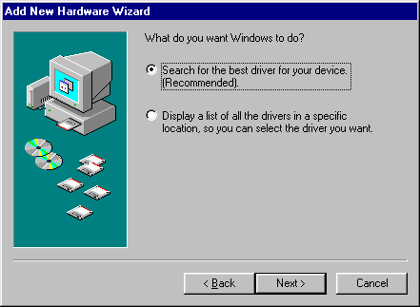

- Click “Next” to continue

- At the next dialogue box select the required choice depending upon driver’s location. If the driver is located in the hard drive specify the location by clicking “Browse”.

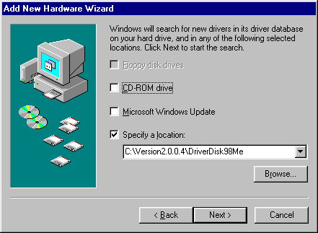

- Click “Next” to continue.

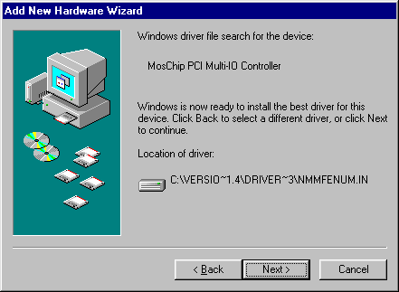

- Ensure whether the path shown by windows is correct or not. Sometimes Windows will find remnants from the previous installation and use that location instead of the new path.

- Click “Next” to continue.

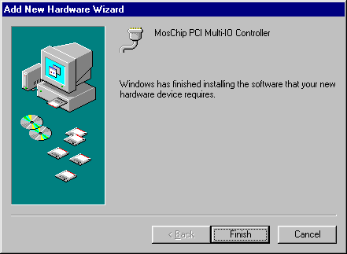

- Click “Finish” to complete the installation.
- Now Windows asks for Reboot. Click “Reboot Now”
- After Rebooting you can check for the Installed driver.

Step3: Driver Installation Check:

Open the Device Manager

Right click on “My computer” icon.
Select “Properties” from the menu.
Click the “Device Manager” tab to show the current hardware list.
- Confirm that MosChip Multi-I/O controller under the category “NMMultiFunction” and MosChip PCI Parallel Port / MosChip PCI Serial Ports under the category Ports (COM & LPT)

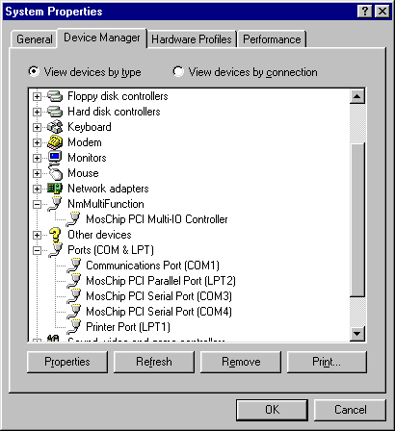

Using Uninstall “NmUninst” Utility:

1. Turn the computer off.
2. Remove the peripheral card.
3. Boot the system normally.
4. Locate the drivers’ path and run NmUninst.

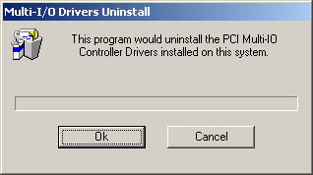

5. Click “OK” to Uninstall.

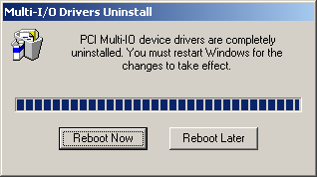

6. Click “Reboot Now” to restart the system. This helps windows for the changes to take effect.
7. Now the drivers will be un-installed completely.
8. The drivers can also be uninstalled from Control panel. Under the control panel select Add/Remove programs and select the device to Uninstall.

For any queries please get in touch with us at support@moschip.com

