Adding Printer Driver Software

The latest PCIeParallel driver software for MCS9901 is released for Mac OS X v10.5 (Leopard). Information about updating and adding the printer driver software in Mac OS X v10.5 is provided below.
If the printer driver set is installed as part of the default Mac OSX v10.5 installation

After completing the Mac OSX v10.5 StarExDriverDisk driver disk, follow these steps to set up a printer queue for the PCIeParallel product.
- Open System Preferences .
- Select Print & Fax and make sure that the list of printer queues includes a printer queue for the PCIeParallel product. Else please wait till it appear.(10Sec approx)
If no printer queue appears for the PCIeParallel product, follow these steps to create a new printer queue:
  - On the left side of the Print & Fax screen, click the plus icon ( ).

  - Figure 1: Print & Fax screen
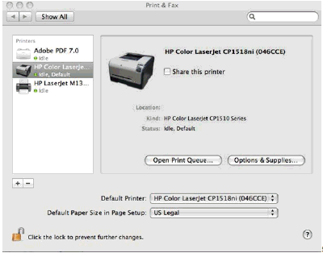
The printer queue addition screen appears.
  - Click to highlight the product that needs a printer queue and then click Add .
 | NOTE: | Depending on the connection speed, it might take as long as a minute to complete the list of products connected to the computer.
  - Figure 2: printer queue addition screen
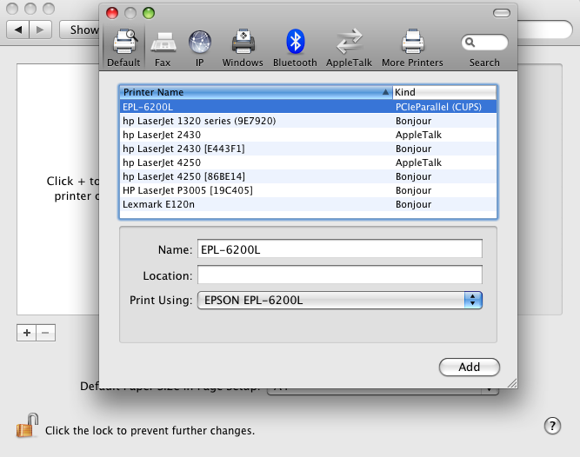
  - The printer queue is created.
If the PCIeParallel printer drivers are not automatically installed as part of the default Mac OSX v10.5 installation
- Insert the Mac OS v10.5 DVD and click the DVD icon to open it.
- Double-click Optional Installs in the lower-right corner of the screen.
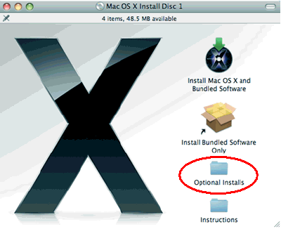
- In the Optional Installs folder, click Optional Installs.mpkg .
Figure 3: Optional Installs folder
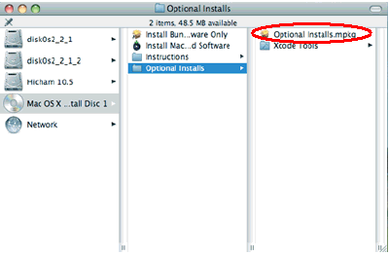
- Click Continue , read the license agreement that appears, and then click Agree to accept the license agreement.
Figure 4: License agreement
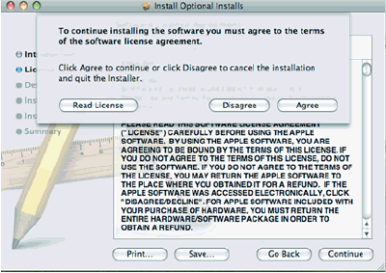
- In the list of printer drivers, scroll down to the printer name conneted to the PCIeParallel port. For example if HP printer is connected, then scroll down to Hewlett-Packard Printer Drivers , select the check box, and then click Continue .
Figure 5: Select Hewlett-Packard printer drivers
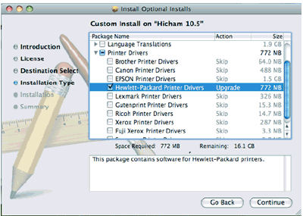
- Click Continue and Install to begin the HP printer driver installation.

If PCIeParallel printer driver is not detected with its default driver for print, please select Generic PCL Laser Printer, 1.3

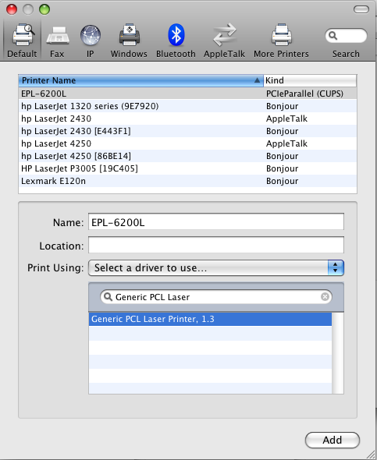

- Click Add and Install to Add the Epson printer in the printer queue addition screen.
8. Select Generic PCL Laser Printer drivers only if default drivers are not detected.

